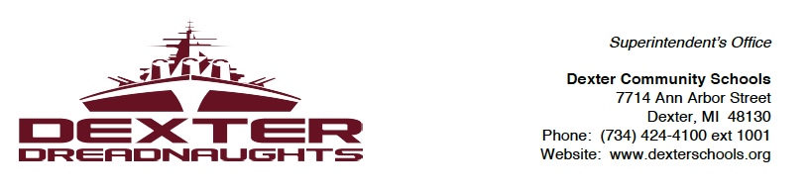

August 20, 2015

Dear DCS Parents and Staff,

The Dexter community is a community of learners. While our students and staff continue to grow skills within our classroom walls, our community has much to share and teach us. As a component of shaping the future of education for your children, we’re looking at unique ways to engage our community and utilize their skills for the benefit of our students. One of these initiatives is a collection of community resources and local businesses interested in helping our students and DCS in unique ways.

Dexter is home to many unique businesses and cutting-edge technologies. Our students are only a few hundred yards from an industrial park that houses incredible knowledge and skills we’d like to share with our students and staff. In particular, we’re interested in knowing if your local business/employer would be willing to:
- Help prepare a video introduction of your company that would be made available for viewing by students
- Give company tours to teachers, parents, and/or students
- Participate in a career fair
- Host an event at your company (e.g., teacher/industry mixer)
- Present in a class during school hours
- Be referred to parents/students as a resource for career advice
- Provide summer (or after-school) internship opportunities to students and/or teachers

If you’re interested and willing to become part of the DCS Community Careers Network, please click here to fill out the Dexter Community Careers Network form.

Thank you for your continued commitment to Dexter Community Schools and Go Dreads!

Sincerely,

Christopher Timmis, Ed.D.
Superintendent

